**Fee Plan**

Sacramento County

Water Agency

Engineer’s Report

For

Zones 11A, 11B, and 11C

Effective Date: _______2015

Draft 11/3/2014gb

**Sacramento County Water Agency Code**

**Zone 11A, 11B, 11C Fee Plan and Engineer’s Report**

On _______ , 2015, by Resolution Number WA _______, the Board of Directors of the Sacramento County Water Agency, a statutorily created district operating under the authority of and pursuant to the provisions of the Sacramento County Water Agency Act (California Water Code, Appendix, Chapter 66, commencing at Section 66-1 et seq.), adopted the _____, 2015 Fee Plan and Engineer’s Report, thereby replacing the previous 2004 Fee Plan and Engineer’s Report (established by Resolution Number WA-2543).

**[insert Resolution WA-_______, dated _______, 2015]**

**Page 2 of the inserted resolution**

**2015 DRAINAGE IMPACT FEE PLAN**

**for ZONES 11A, 11B and 11C**

**TABLE OF CONTENTS**

**2015 DRAINAGE IMPACT FEE PLAN**

**for ZONES 11A, 11B and 11C**

**Background**

This Fee Plan is drawn pursuant to the Water Agency Code, Title 2, specifically, Sections 2.25.020 and 2.25.040, Content of the Fee Plan and Requisite Findings, respectively. The Fee Plan is to be reviewed and adjusted as necessary and periodically, pursuant to Section 2.25.060. This Fee Plan supersedes the 2004 Fee Plan. Where Conflict may arise, the Water Agency Code shall take precedence.

The Sacramento County Department of Water Resources (DWR) is currently revising the drainage fee for Zones 11A, 11B, and 11C. The purpose of this document is to provide the basic assumptions used in developing the fee and the fee rate structure.

**Periodic Fee Revision**

The assumptions and methods used in calculating the new drainage fee are based on the best available information. As future development occurs in each Zone, and master plan improvements are implemented, the fee may be periodically revised based on updated information in order to keep the fee as current as possible.

**Zone 11 History**

Zone 11 of the Sacramento County Water Agency was originally formed in April 1965 with the purpose of providing funding for the construction of major drainage facilities. The area within Zone 11 includes the urbanized and urbanizing areas of the unincorporated portions of the County. All development that contributes to storm water runoff (intensity and/or volume) is required to pay a drainage impact fee to offset the cost of trunk and regional drainage facilities necessitated by development.

Computations were made, in the 1965 study, to determine the average cost of constructing drainage facilities. These costs were based on the type of construction prevalent at the time, primarily pipe and trapezoidal concrete-lined open channels. The total cost of such facilities within Zone 11 was estimated, and a per acre cost was determined. The per acre cost varied for different types of development based on average percent of impervious area. Development was broken into three categories: residential, commercial, and parks.

The fee is adjusted annually, based on the Engineering News Record's Construction Cost Index, to account for inflation of construction costs.

In April 1990, a 15% increase in the drainage fee was approved by the Board to allow for the increased drainage facility construction required for environmental mitigation, including additional channel excavation due to wetlands mitigation, and to mitigate some determined cumulative impacts of urban drainage on downstream properties.

The Fee Plan was revised in 1996 to create Zones 11A, 11B, and 11C and to account for the 1996 City/County of Sacramento Hydrology Standards and to add additional drainage components common to development, including:.

* Flood control detention (local and regional peak flow)
* Water quality facilities (such as detention)
* Environmental mitigation and monitoring
* Master planning costs, including wetlands delineation
* Limited property acquisition
* Upsizing bridges and large culverts for ultimate capacities

Revisions in this 2004 Fee Plan included an analysis of Zone 11 creditable work in current and recent specific plan areas. A questionnaire was sent out to several developers, engineers, and construction companies to review the unit prices paid for items of work on an expanded Schedule D (Appendix 2). The quantities from the specific plan areas were applied to the updated Schedule D prices and totals were quantified for the following major categories of trunk drainage facilities:

* Closed Conduit (Pipes)
* Channel Excavation
* Basin Excavation
* Basin Real Estate
* Channel crossings
* Utility Relocation
* Engineering
* Administration
* Contingency, Interest, In-fill Absorption

In September 2014, the Department of Water Resources received responses from developers and engineers commenting on the trunk drainage unit prices on Schedule D. The basis of this 2015 update to the Fee Plan is an adjustment to those unit prices applied to the trunk drainage item list developed for each of the fee zones.

Plan review labor, legal services, consultants and other overhead costs were reviewed and averaged for fiscal years 2004 through 2007, a time when development activity was vibrant.

**Fee Zones**

Zones 11A, 11B, and 11C (see map, Figure 1) are intended to account for the variability of facilities required within different major watersheds, due primarily to topography and the existence of natural streams versus man-made channels.

The boundaries of each Zone are based on major watershed boundaries. Within each Zone there is a constant fee, regardless of any specific differences in facility needs of the smaller sub-sheds within that Zone. For example, although some sub-sheds may require flood control detention while other sub-sheds do not, the same fee will be required throughout the Zone and regional nexus is found in the fact that each development, whether upstream or downstream, contributes and that people must travel the roadways throughout their region expecting the storm drain systems to function. The Zones 11A, 11B and 11C are described as follows:

* Zone 11 A - Morrison Creek stream group and watersheds draining to the Beach Stone Lake region.
* Zone 11 B - American River tributaries and Arden/Arcade watersheds
* Zone 11 C - Dry Creek and tributaries and watersheds draining to Steelhead Creek (aka. Natomas East Main Drainage Channel).

Zones 11A, 11B, and 11C are regional and overlap the political boundaries of the Cities of Citrus Heights, Rancho Cordova, and Elk Grove. The fees for each Zone are collected and administered by the Sacramento County Water Agency. Each Zone has a separate budget account and the funds are not co-mingled. NOTE: Rancho Cordova and parts of Elk Grove are considering detachment from Zone 11 programs.

The fee program for each Zone is a stand-alone program for the purposes of constructing trunk drainage in that Zone in accordance with Title 2. Developing property in each Zone is benefitted by the fee as either the beneficiary of credits or the user of those trunk drainage facilities within the Zone.

INSERT ZONE 11 MAP

SHOW CITY BORDERS

**Development Classifications and Component Impacts**

There are three basic trunk drainage components: pipes, channels and basins. For purposes of assessing the drainage impact fee, the contribution to the need for each trunk drainage component was considered for a nominal development of various density and corresponding percentage of impervious area. These results were plotted creating a continuum for setting fees for any specific project based on the impervious area of that project.

There will continue to be a different fee for each land use; however, the distinctions are revised (from the 1996 Fee Plan) to reflect the way that increased impervious area impacts (per County Hydrology Standards) the drainage facilities. An effort is made to simplify the method for determining site specific impervious area and the fee is set based on the outcome of this calculation. This is of particular importance in the case of parks and schools for which the impervious area may vary widely. It also creates an incentive for a park, school, and commercial projects to reduce drainage impacts in order to enjoy some relief in the fee charged.

**DRAINAGE FEE CALCULATION**

The drainage fee for each Zone is based on the estimated drainage credits that will be given for installation of trunk drainage facilities, plus engineering, administration, and contingency. The fees and credits will not zero balance on a project by project basis or a year by year basis, rather, the immense infrastructure required to safely convey storm water, flood water and to achieve the goals of the Clean Water Act are estimated over the entirety of each Zone.

Specifically, the fee was determined by:

1. Compilation of estimated trunk drainage facilities, including size and quantity, for each Zone. For Zones 11A and 11C, the estimate was derived from current drainage master plans and specific plan areas. For Zone 11B, the estimate was derived by carrying forward the regional analysis used in the 1996 Fee Plan.

2. Schedule D, unit prices, were updated based on a survey sent out to various developers, engineers, and contractors.

3. Land use was determined based on a county-wide average provided by the Planning Department (see Table 2).

4. The impact of each land use, percent impervious area, was determined using the Hydrology Standards, HEC-1 software, and the Improvement Standards.

5. These component costs were summed.

6. Consulting engineering, administration –external expenditures, Water Resources Department labor, storm water pollution prevention program and minor drainage review labor, National Pollutant Discharge Elimination Program labor, and other County labor were determined as a percentage and applied to the total.

The effective percent impervious area of a site is primarily related to land use; that is, it is assumed that building on the parcel will complete over time to account for the percentages listed in the table below. Therefore, actual calculations of percent impervious area should only be necessary for land uses not listed in Table 1.

Rainfall can infiltrate, evaporate, transpirate, or run-off. Drainage facilities are designed based on estimation of run-off flows using computer modeled design storms. The Sacramento County Improvement Standards and the City/County Hydrology Standards provide a method for designing pipes, channels, and detention basins based on effective percent impervious for various land use. The cost of drainage facilities is increased with the percent impervious area. The basis for fees shall be effective percent impervious area.

**Table 1** (adapted from Table 5-3 of the Sacramento City/County Hydrology Standards- Volume 2 provides, where du/ac is dwelling units per acre) effective increase in percent impervious, since 1965 implementation of the Zone 11 program, as follows:

Highway/Parking 95%

Commercial / office / retail 90%

Industrial 85%

Apartments 31+ du/ac 80%

Mobile Home Park 75%

Apartment/Condo (13-30 du/ac) 70%

Residential 8-10 du/ac 60%

Residential 6-8 du/ac 50%

Residential 4-6 du/ac 40%

Residential 3-4 du/ac 30%

Residential 2-3 du/ac 25%

Residential 1-2 du/ac 20%

Mowed grass with graded and

piped to drain 20%

Residential 0.5-1 du/ac 15%

Residential 0.2-0.5 du/ac 10%

Park without piped drainage 10%

Residential <0.2 du/ac 5%

Open Space 2%

When calculating drainage fees, the following special considerations may apply:

* Traditional school and church campus developments may be treated as 50% impervious area so that they may pay one fee allowing them to build and rebuild without further fee collection.
* Low impact development standards, if applied to the satisfaction of the Agency Engineer effectively reducing peak flow and volume impacts, the fee may be adjusted to as low as RD-5 impact fee amount. If in the future the impact increases, such as due to lack of maintenance, additional drainage fees must be paid.
* No fee is charged for areas encumbered by open space, creeks, bio-swales and detention basins.
* Gravel parking lots, when allowed, may pay the RD-5 fee, and additional drainage fee is due when the percent impervious area increases in the future, for example if the site is paved.
* For custom home developers who intend to sell individual lots, the owner may enter into a constructive notice form, approved by County Counsel, allowing the fee to be paid at transfer of title or deed-of-trust whichever comes first.

**Typical Development**

The Sacramento County Planning Department provided information on typical zoning countywide (Table 2). This information is used to determine the average impervious area and to adjust for the impact in each Zone of the development types and their related impact on the trunk drainage facilities.

**Table 2**

Approximate Acres of Zoning ( Unincorporated County, Elk Grove, Citrus Heights) (1)

|  |  |  |  |  |  |  |
| --- | --- | --- | --- | --- | --- | --- |
|  |  |  |  |  |  | **Determine Average** |
|  |  |  |  | **% impervious** |  | **Impervious** |
|  | **Acres** | **% of Total** |  | **area** | **% land use** | **Area (3)** |
| **RD 1-3** |  |  |  |  |  |  |
| RD 1 | 466.90 |  |  |  |  |  |
| RD 2 | 5342.78 |  |  |  |  |  |
| **Total** | **5809.68** | **9.20%** |  | 20% | 9.20% | 1.84% |
|  |  |  |  |  |  |  |
| **RD 3-5** |  |  |  |  |  |  |
| RD 3 | 2958.49 |  |  | 30% | 4.68% | 1.41% |
| RD 4 | 3288.98 |  |  | 40% | 5.21% | 2.08% |
| RD 5 | 29159.39 |  |  | 40% | 46.17% | 18.47% |
| **Total** | **35406.86** | **56.06%** |  |  |  |  |
|  |  |  |  |  |  |  |
| **RD 5-7** |  |  |  |  |  |  |
| RD 7 | 2884.71 |  |  | 50% | 4.57% | 2.28% |
| **Total** | **2884.71** | **4.57%** |  |  |  |  |
|  |  |  |  |  |  |  |
| **RD 15 - 40 (2)** | **3861.09** | **6.11%** |  | 70% | 6.11% | 4.28% |
|  |  |  |  |  |  |  |
| **Commercial** | **6715.90** | **10.63%** |  | 90% | 10.63% | 9.57% |
|  |  |  |  |  |  |  |
| **Park/Open Space** | **8482.13** | **13.43%** |  | 15% | 13.43% | 2.01% |
|  |  |  |  |  |  |  |
| **Grand Total** | **63160.37** | **100.00%** |  |  | 100.00% | 41.94% |

1. Acreage totals do not include parcels that have more than one zoning (RD 00, Z 00 parcels) nor does it include parcels in Special Planning Areas (SPA)
2. Acreage include single-family houses
3. Determined percent land use from the acreages listed in the second column and multiplied by the percent impervious area. The sum of this column equals the weighted average percent impervious area.

Source of first three columns: Tim Kohaya, Sacramento County Planning Dept.- February 2003

The basic components of the Fee Plan include:

* Closed Conduit (Pipes)
* Channel Excavation
* Basin Excavation
* Basin Real Estate
* Railroad Bridges and Over-chutes
* Utility Relocation
* Engineering
* Zone Administration
* Contingency, Interest, In-fill Absorption

**Fee History**

The Engineering News Record average between two numbers (twenty city average and San Francisco)construction cost index was 6035 in 1996 and 7112 in 2003, amounting to a total inflation increase of 17.8%, the fee was adjusted in 2004 to account for revised credit schedule, construction standards, and analysis more appropriately aligning with the County Hydrology Standards. The construction cost index for 2005 through 2008 increased that fee by 17.88%, then the Board of Directors froze the fee and credit schedules between 2008 and 2013, in 2014, the construction cost index for one year was applied adding 3.85%.

**Credits for Construction of Trunk Drainage**

The overall intention of the trunk drainage fee and credit program is to compensate developers for installing facilities that serve their neighbors. The credits are not intended to fully compensate developers for the drainage facilities presuming that every development would need to establish a drainage system. It is in the best interest of the community to develop drainage systems that are master-planned for the watershed, not merely the interest of an individual development. Consequently, partial compensation for trunk drainage has been the standard for the Agency since 1965.

Minor drainage systems serve less than 30-acres of watershed and trunk drainage serves more than 30-acres. This is a bright line and this program intentionally offers no credits for minor drainage of any sort.

The program is not established in a manner that would be deemed fair to every circumstance. Thus, it is important for property owners to consider their drainage design and the applicability of this fee and credit program before proceeding with their proposed project.

**Measurement and Payment of Credits**

All credits shall be pursuant to Chapter 2.55 of Water Agency Code, Title 2. Where conflicts arise the Water Agency Code shall take precedence.

1. Trunk drainage pipe will be paid by as-built measured lineal foot from center of junction structure or manhole, at the unit prices listed in Schedule D, which includes excavation, traffic control, shoring, bedding and backfill.
2. Four inch thick concrete channel lining shall be paid at the unit price listed in Schedule D. If the design thickness is different than 4”, the revised unit price shall be calculated and paid. That is, a 5” thick lining shall be paid at 125% the price listed per as-built measured square foot. The unit price includes rebar, wire mesh, grading, and all leveling material (aggregate base rock and sand) under the slab.
3. Three foot post and cable fence shall be paid per as-built measured lineal foot at the unit price listed in Schedule D, which includes a complete fence.
4. Pipe gate shall be paid at the unit price per each as listed in Schedule D. This assumes a pipe gate with three or four pipes of 15 foot width and shall be adjusted based on as-built post to post width. For example, an 18 foot wide gate shall be paid at 120% the price listed.
5. Six foot high chain-link fence shall be paid per as-built measured lineal foot at the unit price listed in Schedule D, which includes a complete fence. If the fence is more or less than 6 feet high, the price shall be adjusted. That is, an 8’ high chain-link fence shall be paid at 133% of the price listed.
6. Six foot high chain-link gate shall be paid per each at the unit price listed in Schedule D, which includes a complete fence. This is for a gate width, measured post to post, of 16 feet. If the width is different, the unit price shall be adjusted. That is a 12 foot wide gate shall be at 75% of the unit price listed.
7. Signs required by the Department of Water Resources, or a state or federal resource agency, shall be paid per as-built measured square foot sign face area, at the unit price listed in Schedule D, which includes a complete sign. There are two prices: for 16 square feet or smaller and for signs that are larger than 16 square feet.
8. Miscellaneous metal, such as: handrails, access racks, debris racks, flap gates shall be paid per as-built calculated weight per unit price listed in Schedule D. This information should come in the form of an initial estimate based on the density of the metal and verified by a receipt or invoice from the vender, or other method of checking the weight of material used. Nuts and bolts and minor appurtenances are included in the unit price, and not included in the weight paid. Manhole rims and lids are not miscellaneous metal.
9. Channel excavation shall be paid by as-built measured cubic yard (neat line per the plans) at the unit price listed in Schedule D. Volume can be calculated manually by average end cross section or by digital methods. The same unit price is paid for short haul scraper excavation and for long haul truck export. The original ground for use in determining the excavated quantity shall be the lowest of either the existing ground or the finish development grade.
10. Basin excavation shall be paid by as-built cubic yard at the unit price listed in Schedule D. This can be done manually by average end cross section or by digital methods. The same unit price is paid for short haul scraper excavation and for long haul truck export. The original ground for use in determining the excavated quantity shall be the lowest of either the existing ground or the finish development grade.
11. Erosion control rip-rap shall be paid per as-built ton placed neatly per the approved plans at the unit prices listed on Schedule D. Estimate of tons of rip-rap can be done based on specific gravity and neat lines on plans. The tons shall be verified by weigh slips, if this amount varies from the estimated amount, field measurements to assure that the construction approximates the neat line approved drawings may be required.
12. Access ramps, driveways and maintenance road materials: structural sections of asphalt concrete on aggregate base rock, aggregate base rock alone, decomposed granite, and geotextile fabric shall be paid per as-built square feet at the unit price listed on Schedule D, which includes all appurtenances and no additional compensation shall be allowed.
13. Repairing asphalt concrete surfaces shall be paid per as-built quantities and the unit prices listed in Schedule D. Asphalt concrete patching shall be paid at the listed unit price per square foot regardless of thickness, saw cutting, temporary cut back, trench plates, trench guarantee requirements or traffic control. The measured quantity shall be the t-trench width per the Construction Specifications. This item is only paid when the patch paving is the final accepted product. That is, if the existing asphalt concrete is to remain, patch paving is to be done, and the surface is overlaid or slurry sealed, patch paving shall be credited. However, if the surfacing is removed for a greater width than the trench patch, due to requirements of the inspector or others, patch paving credit shall not be allowed.
14. Repair of concrete sidewalks, curbs and gutters is not credited.
15. Hydroseeding shall be paid per as-built measured area, top of bank to top of bank of the drainage channel only, at the unit price listed on Schedule D.
16. Miscellaneous concrete shall be paid per the as built calculated cubic yard at the unit price listed on Schedule D, and includes (without additional allowance) all rebar, excavation, grading, rock and sand base, and backfill. Miscellaneous concrete is paid in two broad categories: formed structures (junction boxes, headwalls, box culverts, and stairways) and flat work (flat pads, driveways, and weirs). The listing of these items does not infer that they are necessarily creditable. For example, if non trunk drainage pipes coming to a junction with the trunk pipe system create the need for a junction box, the credit shall be the least expensive of the junction box or a manhole that hypothetically would have been used if it were not for the non-trunk pipes. Note that box culverts are almost always paid by the funding mechanism that is construction the roadway and not the Water Agency.
17. Under unusual circumstances trunk drainage construction not listed on Schedule D may be required on the approved improvement plans, in those cases the Board of Directors may authorize credits based on adequate justification of price. Refer also to the appeals process, chapter 1.15 of title 1. Unusual circumstances of construction may not include: construction of minor drainage, construction costs differing from Schedule D, traffic control, excavation depth, shoring, repair of surfaces, trench cut fees, environmental mitigation, pump stations, nor interaction with property owners.
18. Basin real estate shall only be creditable in accordance with Title 2 and as follows:
    1. The basin is deemed to be regionally beneficial for flood control meaning:
    2. Mitigating upstream proposed development and/or correcting existing downstream flooding problems identified in an approved drainage master plan; and
    3. Typically having a side channel weirs adjacent to the channel from which peak flow is to be attenuated by the basin.
    4. When the basin is also used for stormwater quality treatment, the basin land credit will be adjusted to the minimum size necessary for the flood control benefit; and
    5. The value will be determined per Section 2.40 and is necessarily limited by the amount estimated in this fee plan.
    6. The Agency is under no obligation to acquire land, and shall o nly act as a willing buyer when determining the credit agreement value.
    7. There is no land value credits available for stormwater basins or ‘hydromod’ basins.
    8. For combined basins with regionally beneficial flood control, the real estate credit is calculated based on a theoretical stand-alone flood control basin.
19. Items that are expressly not creditable, thus not included in the fee plan, are wetland mitigation, real estate except as stated above, and new pump plants.

**Annual Adjustment of the Fee Schedule “A” and Credit Schedule “D”**

The calendar year 2014 construction cost index (CCI) will be added to the calendar year 2015 CCI and applied in early 2016, per sections 2.50.080 and 2.55.060 of title 2. If that sum exceeds 7 percent, the increase will be capped at 7.0 percent and the balance added to the next year, with the maximum remaining at 7.0 percent annual increase. Should the index be a negative figure, the annual adjustment shall have a lower limit of zero.

**Zone 11A**

Several drainage master plan areas, totaling 7135 acres were considered in updating this Fee Plan and a tabulation of the trunk drainage facilities was compared to the updated Schedule D unit prices. Drainage studies are constantly revising as better detail of the needs for each development plan are known, but the overall average fee component method used in the 2004 Fee Plan has served well and in general is continued in this update.

**Zone 11A Cash Flow**

Accounting for Zone 11A occurs in Fund 315A. The fund is healthy and has been able to pay its reimbursement obligations. This Zone is the fastest growing area of the County. The following tables and chart are based on current assumptions of development in master planned growth areas.

Planning areas considered in developing the fee study include:

* North Vineyard Station having an approved Clean Water Act permit for construction of Elder Creek and Gerber Creek, through 2018. Consequently, the credit/reimbursement estimate is heavily loaded between 2014 and 2018.
* Vineyard Springs will construct improvements on upper Gerber Creek anticipated in the early years of the projection.
* Developers are active in the City of Elk Grove.
* Florin Vineyard Gap development on Elder Creek, Florin Creek and Unionhouse Creek watersheds will include detention, trunk pipes and channel improvements.
* Newbridge, Jackson Township and Mather South are in the planning stage anticipating development interest in coming years.

West Jackson is a plan to redevelop the mining pits on Morrison Creek and is not included in the projection because of mining reclamation exemption in 2.50.060.

Appendix 6 describes the Zone 11A projection of revenue and expenses as one considers groundbreaking on these planning areas. It is assumed that the master developer for each of the planning areas will begin work with heavy front end trunk drainge costs. In later years those plan areas should fill in with development paying cash fees.

**FEE PLAN FOR ZONE 11A - COMPONENTS**

**Closed Conduits (Pipes)**

1. The trunk pipe facilities for several specific plan areas were compared with the new Schedule D credit unit prices to determine this component of the fee plan.
2. Additionally, pipe sizes are increased in Zone 11A due to a revision to the Sacramento County Improvement Standards Section 9-16C:

*Overland flow passing over street vertical curves shall not exceed a depth of six inches (6”) over the back of walk.*

It is found that this new standard is particularly sensitive in areas of flat topography, typical of Zone 11A. This is explained further in the appendix of this document.

**Peak Flow Mitigation**

All piped drainage ultimately discharges to a constructed or natural open channel. Trunk drainage channels are constructed whenever an area cannot be piped either for environmental reasons or when the size of the necessary pipe exceeds 72” diameter. There are also occasions when existing open channel conveyances are widened or otherwise improved.

Channel excavation volumes for several specific plan areas were compared to the new Schedule D credit unit prices to determine this component of the fee plan.

Channel widths are increased in Zone 11A due to the Sacramento County Improvement Standards Section 9-11 in which the Manning’s “n-value” was increased from the previously specified 0.060 to 0.080. This accounts for increased desire to create natural channels with reduced maintenance and better riparian habitat, pursuant to the goals of the Clean Water Act and the Endangered Species Act as well as the desires of the local citizens. This is further described in appendix of this document.

Peak flow mitigation may include the following:

* Concrete lining
* Interpretive signs
* Channel excavation
* Maintenance access
* Fencing
* Hydroseeding
* Existing pump station improvements
* Floodwall to mitigate existing flooding concerns

**Volume Mitigation**

Peak flow detention basins are constructed to attenuate high water to accommodate a downstream constraint or impact to a floodplain or stream confluence. For the improvement of storm water quality, detention volume is often added to the bottom of the flood basin volume creating a wet volume area for settling of particulates from the water.

Volume impacts are accommodated in the form of floodplain management, pump station operation, or detention. Volume impacts were measured for a typical small 160 acre drainage shed, the point at which a large diameter pipe might discharge to a creek, stream or channel.

The total cost of basins included in several drainage master plans for specific plan areas was used to calculate the cost per acre of development. While it is realized that not every development will require a detention basin, the regional nexus is found as discussed earlier in this text and in Titles 1 and 2.

Assuming simple detention basin projects are the typical solution, the volume of storage that would be required was calculated using HEC1 software and the Sacramento Method.

Assumptions used for peak flow and volume:

* SacPre Zone 2, Elevation 100', Slope 0.50%, Soil Type C*, Shed160-acres.
* Conveyance of the 10-year peak flow is conveyed without concern.
* Consider the volume above 10-year peak flow conveyance for build-out of the 160 acres to a total impervious percentage of 15% to 90%.

*NOTE: Soil type D was also run, yielding very similar results.

The above listed impervious percentages and the volume impact above the ten year flow represents a fictitious build out of a 160 acre shed area with one type of development, edge to edge. This is done to determine a relative difference and is not intended to be indicative of any specific site or storm water shed. This is explained further in the appendix of this document.

**Basin Real Estate**

There will be many detention basins of various function in this Zone. Basin real estate credits are necessarily limited only for those basins that are in accordance with the description under Measurement and Payment section above.

**Railroad Bridges**

Occasionally railroad bridges cross over creeks and channels in developing areas must be widened or deepened to allow for the design hydraulics.

**Utility Relocation**

Proper planning and engineering discovery will avoid utility conflicts. When conflicts do arise, the utility is generally required to relocate at no cost to the Agency. There is a nominal budget for utility relocation that is only available when all other avenues are exhausted.

**Engineering**

There is an 8 percent allowance for engineering that is applied to all constructioncomponents (pipes, channels, and detention basins) of the drainage credit agreements. This is not intended to be full compensation; indeed, it is only intended to compensate the developer for a reasonable portion of the engineering costs associated with the fact that trunk drainage facilities typically serve other upstream, downstream and adjacent properties.

**Administration**

Zone 11A administration costs were tabulated below for fiscal year 2001 current as a percentage of the revenue (sum of cash fees and credits), for items 1, 2, and 5 below. Items 3 and 4 are added in this Fee Plan.

1. Administration (external expenditures) includes: legal notices, public outreach, blue printing, copying, postal service, supplies, permits, consultant contracts, fiscal services staff, legal counsel, and specialized computer software.
2. Administration (Department of Water Resources labor) includes staff time reviewing: hydrology and hydraulic analyses, planning applications, improvement plans and environmental documents involving trunk drainage. It also includes administration of the credit and reimbursement agreements pursuant to this Fee Plan.
3. Administration (SWPPP and minor drainage) includes Department of Water Resources staff time reviewing: storm water pollution prevention plans, erosion control plans, grading and drainage for shed areas smaller than 30-acres.
4. Administration (NPDES program labor) includes Department of Water Resources staff time implementing the National Pollution Discharge Elimination System, an ever improving effort to improve the quality of surface water as it is conveyed to streams and rivers.
5. Administration (Other County labor) includes: a nominal budget for handling plan in take and accumulating comments (Land Development and Site Improvement Review), Building Inspection Division’s accounting and cashier services for collection of fees pursuant to the Plan, accounting services for the administration of the Plan, obtaining as-built field quantities, and computer technical support.

The fee component for Department of Water Resources Labor includes master plan review, routine improvement plan review, and administration of the Zone 11A fee plan.

The average of the four years FY03-04 through FY 06-07 is shown below, with calculated average overhead costs.

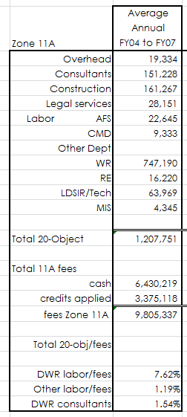

The table below calculates the new average (RD5) fee rate, amounting to a 4.26% fee increase from the effective 2014 fee.

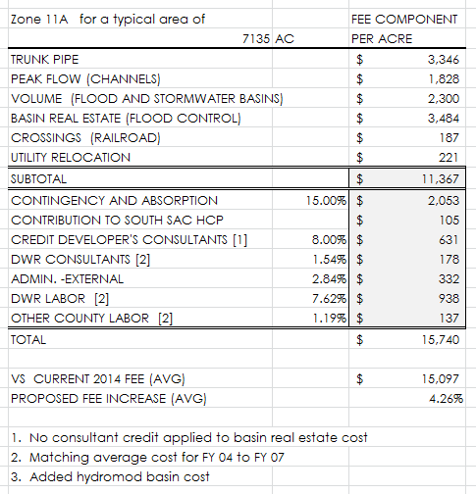

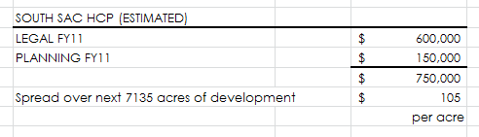

**Contingency and Absorption**

The contingency amount includes, but is not limited to:

1. Appurtenant structures and features to accompany the major trunk drainage facilities, as listed in Schedule D;
2. A nominal allowance development absorption and vacant remainder parcels within the Zones; and
3. Interest costs on reimbursement agreements.

**SUB-FEES WITHIN ZONE 11A**

**Beach Stone Lake Flood Volume Mitigation Fee**

Point Pleasant, Glanville Tract, and Interstate 5 rely upon a railroad (WPRR) grade to function as their upstream levee, and that embankment (which was not constructed to levee standards) failed in both 1986 and 1997. The County is working with State Department of Water Resources (DWR) staff to formulate a project that upgrades existing RD 1002 levees, that improves the function of the WPRR grade pursuant to levee standards, and to evaluate alternatives for protecting the area from south-to-north flows. Finally, there is an effort to examine means of reducing flood hazard upstream of the WPRR.

All of Zone 11A contributes to the Interstate 5 / Point Pleasant Flood Protection Project in the amount of $220.00 per acre (in 2003 dollars) as provided in Schedule 11A and adjusted annually in accordance with Section 2.50 of Title 2. These funds are to be held in reserve for contribution toward a flood damage reduction project that will be formulated by California Department of Water Resources as it advances the CALFED North Delta program in coordination with flood control elements at Lambert Road and Point Pleasant.

This subject has been heard several times by the Board, as of the writing of this document. The project is evolving. The reader interested in the history of the fee is referred to:

* On October 2, 2001, Sacramento County Water Agency Board, Item #32 on October 2, 2001, Coordination of CALFED North Delta Project and Sacramento County’s Interstate 5, Point Pleasant Flood Protection Project;
* Board of Supervisors, Item #60 on November 24, 1998, Beach Stone Lake Flood Control Plan;
* Board of Directors Sacramento County Water Agency, On February 11, 1992 Update on the Lambert Road Flood Control Project…;
* Sacramento County Board of Supervisors, April 17, 1990, Lower Morrison Creek Drainage Improvements…; and
* Sacramento County Board of Supervisors, October 26, 1988, Report Back… Morrison & Laguna Creek Drainage Basin.

The Beach Stone Lake mitigation fee component is described in Appendix 1 fee Schedule “A” and is not revised herein other than to inflate it by the same amount as Zone 11A.

**Zone 11A Fee Reductions**

The following continues as described in the 2004 Fee Plan, which was carried forward since the 1996 Fee Plan. These reduced fees are inflated by the same amount as Zone 11A.

Within the proposed Zone 11A fee area, there are specific developments which were assessed a reduced Morrison Creek Stream Group Fair Share (MCSG) fee rate. These developments are: Laguna West, Lakeside, Elliott Ranch South, Laguna Business Park (Laguna Oaks, Parkside Village), and Calvine-99 SPA (Property “A”).

These developments constructed extensive trunk drainage and detention facilities. Rather than giving them drainage credits against the full fee, they were given a reduction in the old MCSG fee rate based on the value of the facilities constructed. With creation of Zone 11A and its revised fee, in 1996, these areas will be assessed at an appropriately revised fee rate. An explanation of the fee reduction is below.

**Laguna West, Lakeside, Elliott Ranch South**

These developments provided drainage facilities which were allowed to receive full reduction of most component costs of the fee. The exceptions were for trunk pipe and channel construction, which are assessed at the full rate.

**Laguna Business Park (Laguna Oaks, Parkside Village),**

**Calvine-99 SPA (Property “A”)**

These developments provided drainage facilities which were comparable to drainage master plan floodplain corridors. These facilities are located along Elk Grove Creek (Laguna Business Park) and Strawberry Creek (Calvine 99SPA). These facilities were significant in size and allowed for complete reduction of many of the component costs of the fee. The exceptions were for dual-purpose detention construction and property acquisition. For these components the developments received a 56% reduction of the component fee rates. Also, no reduction in component fee rate was given for trunk pipe construction, channel construction or volume detention.

The Zone 11A fees for these aforementioned areas are detailed in fee schedule. They were each increased by an amount associated with the increase in Schedule D and the increased cost of Department of Water Resources staff for plan check and storm water pollution prevention. These fees will be revised annually pursuant to Section 2.50.080.

**Zone 11B**

Zone 11B is that area draining toward the American River. There are numerous opportunities for infill and redevelopment including trunk drainage construction. Department of Water Resources labor costs account for a disproportionate percentage of the revenue due to the size and complexity of infill development activities prevalent in this Zone.

Cash flow for Zone 11B is described in Appendix 5 and 6.

**FEE PLAN FOR ZONE 11B - COMPONENTS**

The following shed areas were studied in the 1996 Fee Plan and the same creditable items used in this 2004 Fee Plan, and continue in this update. The revision considers the effect of the revised Schedule D, plus administration, engineering and contingencies.

|  |  |
| --- | --- |
| Creek | Sample Watersheds net area |
| Chicken Ranch Slough | 2436 acres |
| Strong Ranch Slough | 861 acres |
| Verde Cruz Creek | 888 acres |
| Coyle Creek | 758 acres |
|  | 4943 acres |

The 1996 Fee Plan reduced this gross acreage by 20% for roads and other unbuildable areas:

4943 acres x 80% = 3954 acres.

**Closed Conduit (Pipes)**

In the 1996 Fee Plan, a sample trunk facility inventory was summarized over an area of 4943 acres in the Chicken Ranch Slough, Strong Ranch Slough, Verde Cruz and Coyle Creek watersheds in an effort to determine the typical trunk pipe facilities in Zone 11B. These same figures were used for this 2004 Fee Plan and continue forward in this update.

These pipe and manhole quantities were multiplied by the 2004 Schedule D unit prices to determine the fee component, listed below.

These quantities are carried forward in this 2015 update.

|  |  |  |  |
| --- | --- | --- | --- |
| **Item** |  | **Quantity** |  |
| 21” storm drain pipe |  | 18,125 LF |  |
| 24” storm drain pipe |  | 38,492 LF |  |
| 27” storm drain pipe |  | 7,400 LF |  |
| 30” storm drain pipe |  | 20,320 LF |  |
| 33” storm drain pipe |  | 1,145 LF |  |
| 36” storm drain pipe |  | 19,620 LF |  |
| 42” storm drain pipe |  | 18,978 LF |  |
| 48” storm drain pipe |  | 4,342 LF |  |
| 54” storm drain pipe |  | 5,245 LF |  |
| 60” storm drain pipe |  | 1,990 LF |  |
| 66” storm drain pipe |  | 1,300 LF |  |
| 72” storm drain pipe |  | 1,007 LF |  |
| 84” storm drain pipe |  | 675 LF |  |
| Manholes |  | 233 LF |  |

**Peak Flow Mitigation**

Zone 11B drains to natural streams and legacy channels. Peak flow mitigation may include the following:

* Concrete lining
* Interpretive signs
* Channel excavation
* Maintenance access
* Fencing
* Hydroseeding
* Existing pump station improvements
* Floodwall to mitigate existing flooding concerns

Items that are expressly not creditable, thus not included in the fee plan, are wetland mitigation and channel right of way acquisition.

**Volume Mitigation**

Volume mitigation includes flood control and stormwater quality basins construction for watershed areas greater than 30-acres, including some or all of the following:

* Basin land acquisition when the facility is regionally beneficial flood control for the watershed, approved by the Agency Engineer in accordance with Section 2.40 and in accordance with the requirements found in the Measurement and Payment section of this Plan
* Basin excavation
* Outlet features
* Maintenance access
* Fencing
* Hydroseeding

**Railroad Bridges**

There are no railroad bridges included in this fee.

**Utility Relocation**

Proper planning and engineering discovery will avoid utility conflicts. When conflicts do arise, the utility is generally required to relocate at no cost to the Agency. There is a nominal budget for utility relocation that is only available when all other avenues are exhausted.

**Engineering**

There is an 8 percent allowance for engineering that is applied to all constructioncomponents (pipes, channels, and detention basins) of the drainage credit agreements. This is not intended to be full compensation; indeed, it is only intended to compensate the developer for a reasonable portion of the engineering costs associated with the fact that trunk drainage facilities typically serve other upstream, downstream and adjacent properties.

**Administration**

Zone 11B administration costs were tabulated below for fiscal year 2001 current as a percentage of the revenue (sum of cash fees and credits), for items 1, 2, and 5 below. Items 3 and 4 are added in this Fee Plan.

1. Administration (external expenditures) includes: legal notices, public outreach, blue printing, copying, postal service, supplies, permits, consultant contracts, fiscal services staff, legal counsel, and specialized computer software.
2. Administration (Department of Water Resources labor) includes staff time reviewing: hydrology and hydraulic analyses, planning applications, improvement plans and environmental documents involving trunk drainage. It also includes administration of the credit and reimbursement agreements pursuant to this Fee Plan.
3. Administration (SWPPP and minor drainage) includes Department of Water Resources staff time reviewing: storm water pollution prevention plans, erosion control plans, grading and drainage for shed areas smaller than 30-acres.
4. Administration (NPDES program labor) includes Department of Water Resources staff time implementing the National Pollution Discharge Elimination System, an ever improving effort to improve the quality of surface water as it is conveyed to streams and rivers.
5. Administration (Other County labor) includes: a nominal budget for handling plan in take and accumulating comments (Land Development and Site Improvement Review), Building Inspection Division’s accounting and cashier services for collection of fees pursuant to the Plan, accounting services for the administration of the Plan, obtaining as-built field quantities, and computer technical support.

The fee component for Department of Water Resources Labor includes master plan review, routine improvement plan review, and administration of the Zone 11B fee plan.

The average of the four years FY03-04 through FY 06-07 is shown below, with calculated average overhead costs.

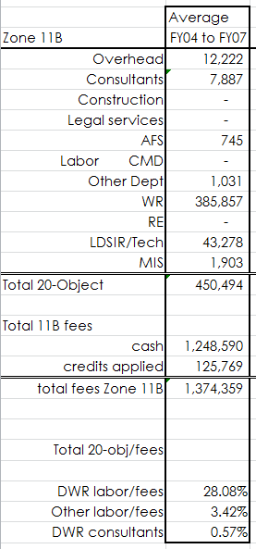

The table below calculates the new average (RD5) fee rate, amounting to a 1.48% fee increase from the effective 2014 fee.

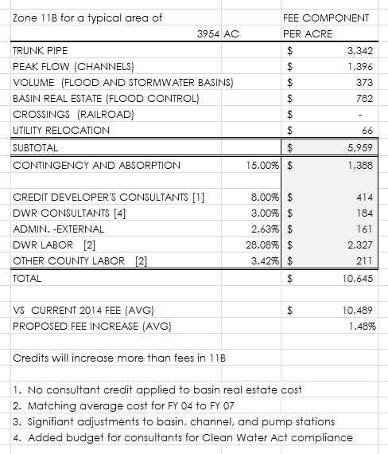

**Contingency and Absorption**

The contingency amount includes, but is not limited to:

1. Appurtenant structures and features to accompany the major trunk drainage facilities, as listed in Schedule D;
2. A nominal allowance development absorption and vacant remainder parcels within the Zones; and
3. Interest costs on reimbursement agreements.

**Zone 11C**

Zone 11C is that area draining to Dry Creek or to Natomas East Main Drainage Canal (Steelhead Creek). It includes Elverta, Rio Linda, Antelope and parts of Orangevale. There remain significant opportunities for growth in these areas.

The largest development area is the Elverta Specific Plan.

Cashflow for Zone 11C is described in Appendix 5 and 6.

**FEE PLAN FOR ZONE 11C**

**Closed Conduit (Pipes)**

The trunk pipe facilities estimated for Elverta Specific Plan 2014 draft trunk drainage finance estimate were compared with the new Schedule D credit unit prices to determine this component of the fee plan.

**Peak Flow Mitigation**

All piped drainage ultimately discharges to a constructed or natural open channel. Trunk drainage channels are constructed whenever an area can not be piped either for environmental reasons or when the size of the necessary pipe exceeds 72” diameter. There are also occasions when existing open channel conveyances are widened or otherwise improved.

1. Channel excavation volumes for several specific plan areas were compared to the new Schedule D credit unit prices to determine this component of the fee plan
2. Channel widths are increased in Zone 11A due to the Sacramento County Improvement Standards Section 9-11 in which the Manning’s “n-value” was increased from the previously specified 0.060 to 0.080. This accounts for increased desire to create natural channels with reduced maintenance and better riparian habitat, pursuant to the goals of the Clean Water Act and the Endangered Species Act as well as the desires of the local citizens. This is further described in the appendix.
3. Storm Water Quality is improved by careful design of channel bottom grading and planting.

Peak flow mitigation may include the following:

* Concrete lining
* Interpretive signs
* Channel excavation
* Maintenance access
* Fencing
* Hydroseeding
* Existing pump station improvements
* Floodwall to mitigate existing flooding concerns

**Volume Mitigation**

Peak flow detention basins are constructed to attenuate high water to accommodate a downstream constraint or impact to a floodplain or stream confluence. For the improvement of storm water quality, detention volume is often added to the bottom of the flood basin volume creating a wet volume area for settling of particulates from the water.

Volume impacts are accommodated in the form of floodplain management, pump station operation, or detention. Volume impacts were measured for a typical small 160 acre drainage shed, the point at which a large diameter pipe might discharge to a creek, stream or channel.

The total cost of basins included in several drainage master plans for specific plan areas was used to calculate the cost per acre of development. While it is realized that not every development will require a detention basin, the regional nexus is found as discussed earlier in this text and in Titles 1 and 2.

Assuming simple detention basin projects are the typical solution, the volume of storage that would be required was calculated using HEC1 software and the Sacramento Method.

Assumptions used for peak flow and volume:

* SacPre Zone 2, Elevation 100', Slope 0.50%, Soil Type C*, Shed 160-acres.
* Conveyance of the 10-year peak flow is conveyed without concern.
* Consider the volume above 10-year peak flow conveyance for build-out of the 160 acres to a total impervious percentage of 15% to 90%.

*NOTE: Soil type D was also run, yielding very similar results.

The above listed impervious percentages and the volume impact above the ten year flow represents a fictitious build out of a 160 acre shed area with one type of development, edge to edge. This is done to determine a relative difference and is not intended to be indicative of any specific site or storm water shed.

This is further described in the appendix.

**Basin Real Estate**

Credits for basin land shall only be available for regionally beneficial flood control facilities with side channel weirs adjacent to the channel from which peak flow is to be attenuated by the basin. When the basin is also used for stormwater quality treatment, the basin land credit will be adjusted to the minimum size necessary for the flood control benefit.

Value shall be determined per Section 2.40 and is necessarily limited by the amount estimated in this fee plan. The Agency is under no obligation to acquire land, and shall only act as a willing buyer when determining the credit agreement value.

There is no land value credits available for stormwater basins or ‘hydromod’ basins.

**Utility Relocation**

Proper planning and engineering discovery will avoid utility conflicts. When conflicts do arise, the utility is generally required to relocate at no cost to the Agency. There is a nominal budget for utility relocation that is only available when all other avenues are exhausted.

**Engineering**

There is an 8 percent allowance for engineering that is applied to all constructioncomponents (pipes, channels, and detention basins) of the drainage credit agreements. This is not intended to be full compensation; indeed, it is only intended to compensate the developer for a reasonable portion of the engineering costs associated with the fact that trunk drainage facilities typically serve other upstream, downstream and adjacent properties.

**Administration**

Zone 11C administration costs were tabulated below for fiscal year 2004 to 2007 as a percentage of the revenue (sum of cash fees and credits), for items 1, 2, and 5 below. Items 3 and 4 are added in this Fee Plan.

1. Administration (external expenditures) includes: legal notices, public outreach, blue printing, copying, postal service, supplies, permits, consultant contracts, fiscal services staff, legal counsel, and specialized computer software.
2. Administration (Department of Water Resources labor) includes staff time reviewing: hydrology and hydraulic analyses, planning applications, improvement plans and environmental documents involving trunk drainage. It also includes administration of the credit and reimbursement agreements pursuant to this Fee Plan.
3. Administration (SWPPP and minor drainage) includes Department of Water Resources staff time reviewing: storm water pollution prevention plans, erosion control plans, grading and drainage for shed areas smaller than 30-acres.
4. Administration (NPDES program labor) includes Department of Water Resources staff time implementing the National Pollution Discharge Elimination System, an ever improving effort to improve the quality of surface water as it is conveyed to streams and rivers.
5. Administration (Other County labor) includes: a nominal budget for handling plan in-take and accumulating comments (Land Development and Site Improvement Review), Building Inspection Division’s accounting and cashier services for collection of fees pursuant to the Plan, accounting services for the administration of the Plan, obtaining as-built field quantities, and computer technical support.

The fee component for Department of Water Resources Labor includes master plan review, routine improvement plan review, and administration of the Zone 11C fee plan.

The average of the four years FY03-04 through FY 06-07 is shown below, with calculated average overhead costs.

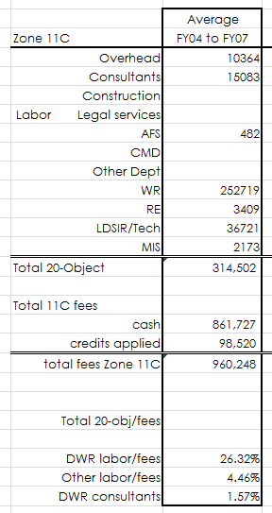

The table below calculates the new average (RD5) fee rate, amounting to a 7.00% fee increase from the effective 2014 fee.

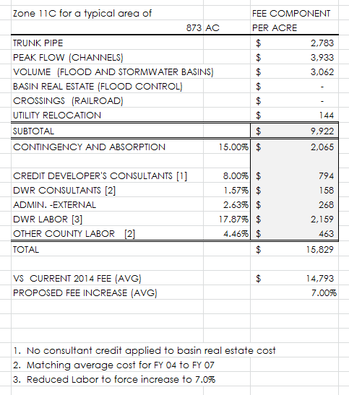

**Contingency and Absorption**

The contingency amount includes, but is not limited to:

1. Appurtenant structures and features to accompany the major trunk drainage facilities, as listed in Schedule D;
2. A nominal allowance development absorption and vacant remainder parcels within the Zones; and
3. Interest costs on reimbursement agreements.

**SUB-FEES WITHIN ZONE 11C**

The sub zones are carried forward without edit pursuant to the 2004 fee plan.

These subzone fee components are inflated at the same rate as Zone 11C.

**Placer County Dry Creek Fair Share Fees**

This supplemental fee is for the mitigation of impacts within Placer County and shall only be collected from new construction/development of properties that drain to Placer County. Linda Creek flows into Roseville and ultimately into Dry Creek consequently having a different impact and different fee than that amount charged to new construction in the portion of the Antelope area that drains toward Placer County. These fees are deposited to sub-accounts of Zone 11C and sent annually to Placer County where they are held in trust for specific improvements described in the Dry Creek Drainage Master Plan.

History:

On October 6, 1987 a Memorandum of Understanding Concerning Flood Control, Drainage, and Water Conservation Activities in Placer, Sacramento and Sutter Counties and the City of Sacramento was signed (WA Resolution #779).

In April 1992, the Placer County Flood Control and Water Conservation District and Sacramento County Water Agency Final Report Dry Creek Flood Control Plan was published. The Plan recommends six structural and non-structural program elements as follows:

* Local detention basins;
* Regional detention basins;
* Channel improvements, levees, and floodwalls;
* Bridge and culvert improvements;
* Floodplain management; or
* Regional data acquisition and flood warning system.

January 23, 1996 Resolution 96-0056 and WA Resolution #2202 approved the Dry Creek Watershed Flood Control Program Final Environmental Impact Report (Control Number 95-0577). These resolutions found that the Final Environmental Impact Report for the Dry Creek Watershed Flood Control Program was adequate and agreed to establish a fair share fee for contribution to the project.

March 19, 1996 letter to the Board of Supervisors titled Linda Creek Fair Share Contribution Condition (filed March 26, 1996, numbered as 19).

**Dry Creek Watershed (flowing north across the County line and into Dry Creek) --**

Prior to improvement plan approval or recordation of the final map, whichever occurs first, a drainage fee as identified in the Placer County Dry Creek Watershed Flood Control Plan shall be paid. In 1996, the amount of the fee was $950.00 per acre for commercial and industrial land uses, and $125.00 per residential unit.

The fee shall be inflated now, and in the future inflated annually, by the ENR Construction Cost Index. The 1996 fee is increased 17.8% to 2003 dollars to $1119 per acre for commercial and industrial uses, and $147 per residential unit.

These funds are remitted annually to Placer County where they are to be held in interest bearing trust and used for activities specified in the April 1992 Plan or as amended. This fee shall continue to be deemed interim and shall be subject to periodic review.

**Linda Creek Watershed –**

Payable prior to improvement plan approval or recordation of the final map, whichever occurs first, a fair share contribution. In 1996, the fair share contribution was $621 per acre for commercial and industrial land uses, and $490 per residential unit.

The fee shall be inflated now, and in the future inflated annually, by the ENR Construction Cost Index. The 1996 fee is increased 17.8% to 2003 dollars to $731 per acre for commercial and industrial uses, and $577 per residential unit (not to exceed $731 per acre).

These funds are remitted annually to Placer County where they are to be held in interest bearing trust and used for activities specified in the April 1992 Plan or as otherwise amended. This fee shall continue to be deemed interim and shall be subject to periodic review.

**Steelhead Creek Fair Share Fee**

The area east of Steelhead Creek (also known as the Natomas East Main Drain Tributaries, NEMDC) flooded in 1986 and again in 1995. High water was measured at an elevation of nearly 37 feet at Elkhorn Blvd and Elverta Road. Subsequent construction of the D15 pump station (including three pumps totaling 1000 cubic feet per second and an automatic gravity outlet) lowered the 100-year FEMA floodplain adjacent to the channel levee to elevation 31 feet at Elkhorn Blvd and 32.5 feet one mile north of Elverta Road. The Sacramento County Department of Water Resources regulates new construction using a conservative floodplain of elevation that is 2.2’ higher than the FEMA map. This allows for the possibility of one pump being out of service during a 100-year storm.

D15 pump station serves to lower the water surface elevation inside of the NEMDC levees by blocking Dry Creek backwater from backing up the canal while pumping the water into the downstream higher water surface. This system allows for gravity outfall from the 17,216 acres draining to the east side of NEMDC.

According to engineering analysis, when development of the basin east of NEMDC is completed, the all three pumps running scenario will yield a higher 100-year water surface elevation upstream of D-15 pump station, calculated to rise 1.2 feet, at the Elkhorn Blvd bridge. Therefore, in order to maintain the current regulated floodplain with the possibility of one pump failing during the 100-year event, one must add a fourth pump.

While the repair and replacement cost of the existing facility will be paid by other funds, the cost of mitigation due to volume impacts attributed to development should be an anticipated future cost of this Zone 11C Fee Plan.

Estimated cost to add a fourth pump to the D-15 Pump Station is $3,000,000 (based on other pump plants recently constructed and original cost of existing D-15). If it is constructed after 65% build out of the area, the fee per acre shall be:

($3,000,000 ÷ 17216 acres) ÷ 65% = $268 per acre

**Annual Fee Adjustment**

Steelhead Creek Volume Mitigation Fee is adjusted annually.

Referring to volume impacts, see Table H in Appendix 3 of this text, and assuming an average one acre residential zoning (percent impervious area of 20%) the fee shall be apportioned according to the adjusted component impact. This amount will be inflated annually, per Section 2.50.080. This fee is detailed on the Zone 11C Fee Schedule.

The basin impact percentages are the same as those used in Zone 11A and 11C volume component calculations earlier in this text. The pump station D-15 component is centered around a typical 20% impervious area for the basin at build out. That is 63.42% is to 100% as 108.24% is to 171%. Therefore, the fee for a proposed development that has 50% impervious area is $457 per acre (2004 Fee Plan).

The fee described above is inflated by the construction cost index through 2008, plus the CCI for 2013, and the adjustment for 11C fee for this fee study update.

**APPENDICES**

1. Schedule A – Zone 11A, 11B, 11C Fees
2. Schedule D Unit Prices – for Credit Agreements
3. Comparison of Closed Conduit (Pipe) Size for Commercial versus Residential Development; Channel (Peak Flow) Impact; Basin (Volume) Impact; Reduce Fee for Parks and Schools
4. Impact of Section 9-16C (Improvement Standards) on Pipe Size
5. Cost Summary, Compare Fee for 5-acre Development, Summary of Component Impacts
6. Four Year Summary of Administration Costs
7. History of Zone 11 (Fees, Credits, Interest Rates)
8. Template for Assignment of Drainage Credits Agreement

**APPENDIX 1**

Schedule A – Zone 11A, 11B, 11C Fees

[INSERT 4 SHEETS – SCHEDULE A – ZONE 11 FEES]

**APPENDIX 2 Schedule D Unit Prices**

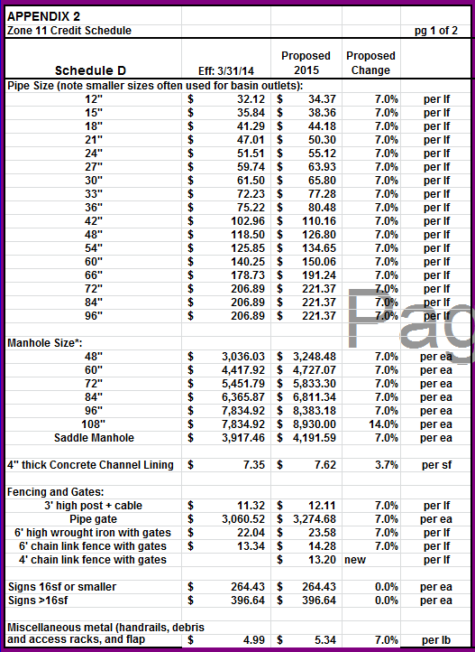

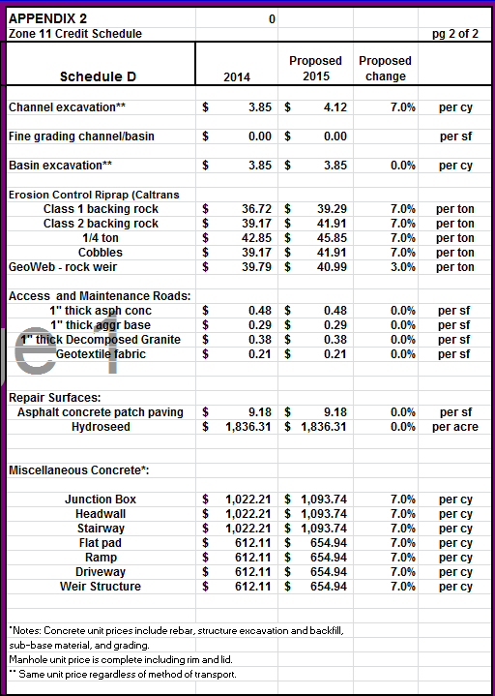

**APPENDIX 3 Development Impact Analysis**

This appendix continues forward pursuant to the 2004 Fee Plan.

Parts:

* Commercial versus Residential Pipe Standards.
* Channel Impact (peak flow)
* Basin Impact (flood and water quality volume)
* Reduce Fee for Parks and Schools

**Commercial versus Residential**

The County Improvement Standards have two pipe design curves, residential and commercial. Commercial includes dense residential and industrial, while the residential curve is used for parks and schools. The following will compare these two design curves to determine the appropriate weighting of the total estimated cost of trunk pipe drainage. Consider a fictitious square 240-acre drainage shed in Nolte zone 3:

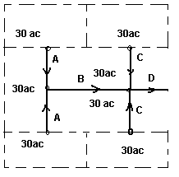

|  |  |  |  |  |  |  |
| --- | --- | --- | --- | --- | --- | --- |
|  | | | Zone 3 "Nolte Method" | |  |  |
| PIPE | LENGTH (ft) | SHED | Residential |  | Commercial |  |
| A | 1616 | 30ac | 7.5cfs | 21" | 15cfs | 27" |
| B | 1616 | 90ac | 32cfs | 36" | 42cfs | 42" |
| C | 1616 | 30ac | 7.5cfs | 21" | 15cfs | 27" |
| D | 808 | 210ac | 106cfs | 54" | 124cfs | 60" |

|  |  |  |  |  |  |  |  |  |
| --- | --- | --- | --- | --- | --- | --- | --- | --- |
| Residential | |  |  |  | Commercial | |  |  |
| 21" | 3232 | ft | $ 124,109 |  | 27" | 3232 | ft | $ 157,722 |
| 36" | 1616 | ft | $ 99,287 |  | 42" | 1616 | ft | $ 135,906 |
| 54" | 808 | ft | $ 83,062 |  | 60" | 808 | ft | $ 92,564 |
|  |  |  | $ 306,458 |  |  |  |  | $ 386,192 |

$386,192 divided by $306,458 equals 1.26. Therefore, one can see that the impact to trunk pipe drainage is 26% greater for commercial development than that required for residential developments.

|  |  |  |
| --- | --- | --- |
| **Table G** |  |  |
| HEC-1 Output | |  |
| SacPre Zone 2, elevation 100', soil C | | |
| 160-acres, L=2640', Lc=1320' | | |
| Impervious Area | Peak Flow |  |
| 5% | 158.5 | cfs |
| 15% | 246.1 | cfs |
| 20% | 255.3 | cfs |
| 30% | 279.2 | cfs |
| 40% | 296.1 | cfs |
| 50% | 306.4 | cfs |
| 60% | 321.5 | cfs |
| 70% | 333.8 | cfs |
| 80% | 346.4 | cfs |
| 90% | 358.6 | cfs |

**Channel Impacts**

To determine the channel component impact of various development types based on impervious area, a small shed area of 160 acre was considered. This shed area seems to be typical of pipe conveyance to an open channel. The peak 100-year flow for the average imperviousness (41.94% per Table 2) was used to compare the peak flow impact of each type of development ranging from 15% to 90% impervious area.

HEC-1 output, for various impervious area percentages, is contained in Table G for a 160-acre square shed with soil type C, a slope of 0.50%, at elevation 100 feet. The weighted impact is determined by centering over the 41.94% impervious area “average development”, 298.1 cfs (interpolated) peak flow.

For example, if the entire 160-acre shed is made up of development that is 20% impervious, the peak flow is 255.3 cfs which is 85.64% (255.3 ÷ 298.1) of the peak flow impact compared to what it would be if the area was all developed at 41.94% imperviousness. Likewise, if it is all developed at 80%, the impact is 116.20% of that of the average development. These results are tabulated in Table H.

**Impact of increased Manning’s n-value.**

Due to various state and federal wildlife regulations and a desire of many to maintain drainage channels and creeks to a minimum level to allow for habitat, and pursuant to the updated County Improvement Standards, the Manning’s roughness coefficient (n-value) will typically be 0.080. This is an increase from the previous 0.060 that was used as a basis for the 1996 Fee Plan channel component.

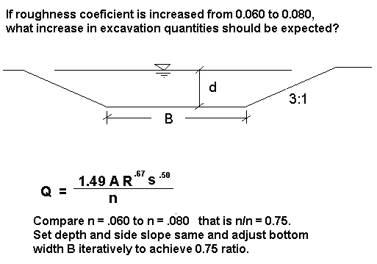

Starting with a bottom width B1 and calculating the wetted perimeter P1 and the hydraulic cross sectional area A1 and the area times the 2/3 root of the hydraulic radius (R1) then by iterating B2 until the resultant ratio of A times the 2/3 root of R is 0.75, one may solve for the cross sectional area A2 and determine the increased excavation quantity, due to increasing the Manning’s n-value from 0.060 to 0.080 (described in the figure above). Table I is a compilation of channels 6 feet and 8 feet deep with bottom widths of 10 feet to 100 feet.

In the first example, a 6’ deep channel is 10 feet wide at the bottom if n=0.060. Increasing n to 0.080 increases the bottom width to 17.3’ and the cross sectional area by 26% (B2 was manually input into the Excel spreadsheet until the ratio on the right came to 0.75).

Looking at the comparisons on Table I, the average is (1.31+1.31+1.28+1.29+1.26+1.26)/6 = 1.29. Therefore, it is found that there is an average 29% increase in the cost of channel excavation quantities due to increasing Manning’s n-value from 0.060 to 0.080. It is noted that not every channel will be built at 0.080, but there will be an overall proportionate increase in roughness coefficients for constructed channels.

**Volume Impacts**

To determine the volume impact of various development types based on impervious area, a small shed of 160-acre was considered, as it was for channel impacts. The 100-year flow was calculated using the Sacramento Method and HEC-1 software assuming soil type C, 0.50% slope, elevation 100’ and a square 160-acre drainage shed area in Sacramento hydrology zone 2.

One may assume that in almost every case the 10-year flow can be conveyed without consequence. Volume impacts, therefore, are not a concern until a storm exceeds the 10% annual recurrence level. For this study, the Sacramento 10-year flow was calculated and the volume above this flow was determined (see Table J).

The countywide average impervious area (Table 1) of 41.94% contributes 2.23 acre feet (interpolated) of volume above the 10-year flow. The impact of a range of impervious area percentages was developed centered around this average. That is, if the 160-acre shed is developed at 15% impervious area, the volume impact is 55.0% of that of the average development. While an 80% impervious development is 38.6% greater than the average (3.09AF ÷ 2.23AF).

It is recognized that not every shed will require peak flow attenuation; however, this comparison is deemed appropriate when considering how to best spread the cost of volume mitigation over an entire Zone.

**Table H**

|  |  |  |  |  |
| --- | --- | --- | --- | --- |
| **% impervious area** | **peak flow (cfs)** | **volume exceeding 10yr (ac-ft)** | **channel impact** | **volume impact** |
| **15%** | 246.1 | 1.23 | 82.55% | 55.04% |
| **20%** | 255.3 | 1.40 | 85.64% | 62.87% |
| **30%** | 279.2 | 1.88 | 93.68% | 84.29% |
| **40%** | 296.1 | 2.19 | 99.32% | 98.24% |
| **50%** | 306.4 | 2.39 | 102.80% | 107.32% |
| **60%** | 321.5 | 2.65 | 107.86% | 119.19% |
| **70%** | 333.8 | 2.87 | 111.98% | 128.80% |
| **80%** | 346.4 | 3.09 | 116.20% | 138.62% |
| **90%** | 358.6 | 3.29 | 120.29% | 147.60% |
|  |  |  |  |  |
| **41.94%\*** | 298.1 | 2.23 |  |  |

* calculated by interpolation.

**Table I**

|  |  |  |  |  |  |  |  |  |  |
| --- | --- | --- | --- | --- | --- | --- | --- | --- | --- |
|  |  |  |  |  |  |  |  |  |  |
| If Manning's "n" value is increased from 0.060* to 0.080, the effect is as follows: | | | | | | | | | |
|  |  |  |  |  |  |  |  |  |  |
|  |  | bottom width |  | area |  | wetted perimeter |  |  | Ratio |
| depth | B1 = | 10.0 | A1 = | 168.0 | P1 = | 46.0 |  | 400.1 |  |
| 6 | B2 | 17.3 | A2 | 211.8 | P2 | 53.3 |  | 533.8 | 0.75 |
|  |  |  |  | 126% |  |  |  |  |  |
|  |  |  |  |  |  |  |  |  |  |
| depth | B1 | 10.0 | A1 | 272.0 | P1 | 58.0 |  | 766.0 |  |
| 8 | B2 | 18.8 | A2 | 342.4 | P2 | 66.8 |  | 1023.5 | 0.75 |
|  |  |  |  | 126% |  |  |  |  |  |
|  |  |  |  |  |  |  |  |  |  |
| depth | B1 | 50.0 | A1 | 408.0 | P1 | 86.0 |  | 1157.9 |  |
| 6 | B2 | 70.0 | A2 | 528.0 | P2 | 106.0 |  | 1548.3 | 0.75 |
|  |  |  |  | 129% |  |  |  |  |  |
|  |  |  |  |  |  |  |  |  |  |
| depth | B1 | 50.0 | A1 | 592.0 | P1 | 98.0 |  | 1975.4 |  |
| 8 | B2 | 71.0 | A2 | 760.0 | P2 | 119.0 |  | 2632.3 | 0.75 |
|  |  |  |  | 128% |  |  |  |  |  |
|  |  |  |  |  |  |  |  |  |  |
| depth | B1 | 100.0 | A1 | 708.0 | P1 | 136.0 |  | 2138.4 |  |
| 6 | B2 | 136.0 | A2 | 924.0 | P2 | 172.0 |  | 2850.2 | 0.75 |
|  |  |  |  | 131% |  |  |  |  |  |
|  |  |  |  |  |  |  |  |  |  |
| depth | B1 | 100.0 | A1 | 992.0 | P1 | 148.0 |  | 3548.9 |  |
| 8 | B2 | 138.0 | A2 | 1296.0 | P2 | 186.0 |  | 4758.6 | 0.75 |
|  |  |  |  | 131% |  |  |  |  |  |
|  |  |  |  |  |  |  |  |  |  |
| Notes: |  |  |  |  |  |  |  |  |  |
| Middle Branch Strawberry Creek was the basis for the Green Book (1996 Fee Plan) | | | | | | | | | |
| analysis, with an "n" of 0.060, per Heidi Huber (County DWR staff). | | | | | | | | |  |
| B2 is input iteratively until the ratio becomes 0.75 | | | | | |  |  |  |  |

**Table J**

|  |  |  |  |
| --- | --- | --- | --- |
|  |  |  |  |
| SacPre Zone 2, elevation 100', Slope 0.50% | | | |
| Soil type C, 160 acres | |  |  |
| L=2640', Lc=1320' | |  |  |
| Impervious Area | Volume above 10-year | |  |
| 15% | 1.23 | acre-feet |  |
| 20% | 1.40 | acre-feet |  |
| 30% | 1.88 | acre-feet |  |
| 40% | 2.19 | acre-feet |  |
| 50% | 2.39 | acre-feet |  |
| 60% | 2.65 | acre-feet |  |
| 70% | 2.87 | acre-feet |  |
| 80% | 3.09 | acre-feet |  |
| 90% | 3.29 | acre-feet |  |

**Possible Reduced Fee for Parks and Schools**

The following is a comparison of impacts from the spreadsheets titled Summary of Component Impact for Zones 11A, 11B, and 11C. Schools and parks typically fall within the 20% to 50% impervious area range. As one can see, the average impact exceeds 50%. This serves to justify the reduction in fees when schools and parks include peak flow and volume attenuation in their grading plans, pursuant Section 2.50.050.

|  |  |  |  |  |
| --- | --- | --- | --- | --- |
| **50% Impervious Area** | **Peak Flow** | **Volume** | **Basin Real Estate** | **Sum** |
| **11A** | 21.00 | 15.75 | 32.10 | 68.85 |
| **11B** | 23.76 | 11.24 | 17.54 | 52.54 |
| **11C** | 47.67 | 9.79 | 21.03 | 78.49 |
| **Average** | 30.81 | 12.26 | 23.56 | 66.63 |
|  |  |  |  |  |
| **20% Impervious Area** | **Peak Flow** | **Volume** | **Basin Real Estate** | **Sum** |
| **11A** | 17.49 | 9.23 | 18.80 | 45.52 |
| **11B** | 19.79 | 6.58 | 10.28 | 36.65 |
| **11C** | 39.72 | 5.73 | 12.52 | 57.97 |
| **Average** | 25.67 | 7.18 | 13.87 | 46.71 |
|  |  |  |  |  |
| **Average 20% and 50% Imp Area** | **Peak Flow** | **Volume** | **Basin Real Estate** | **Sum** |
| **11A** | 19.25 | 12.49 | 25.45 | 57.19 |
| **11B** | 21.78 | 8.91 | 13.91 | 44.60 |
| **11C** | 43.70 | 7.76 | 16.78 | 68.23 |
| **Average** | 28.24 | 9.72 | 18.71 | 56.67 |

**APPENDIX 4 Pipe Sizing Analysis**

This appendix continues forward pursuant to the 2004 Fee Plan.

**Impact of Section 9-16C on Pipe Sizes**

Pipes are designed to convey a finite flow; however, sometimes nature delivers bigger storms. During these high intensity storms, piped storm drain systems may become overwhelmed. Inlets surcharge, storm water ponds in low areas until they are full and flows over land to creeks, streams, basins, channels and ditches. The depth of the over-land flow in the street can be calculated and the building can safely be constructed above the 100-year water surface; however, there is a concern about the depth of flowing water in a street (see figure below). In the 2002 revision to the Drainage Improvement Standards, the Department of Water Resources added Section 9-16C, as follows:

*Overland flow passing over street vertical curves shall not exceed a depth of six inches over the back of walk.*

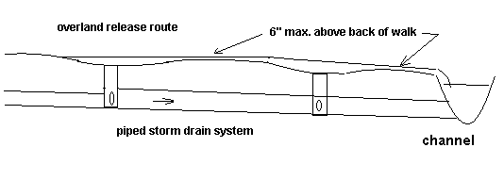

Flow versus depth was calculated using normal flow and Manning’s Equation. This relationship for a 40’ wide street right of way is graphically represented in the following chart, “Overland Release 40’ Right of Way half section street flow”. This is linked, in Excel to Table B4.

Manning’s equation was used, assuming normal flow in full pipes, to determine pipe sizes based on the Sacramento County Improvement Standards (aka. the Nolte runoff curves). The 100-year curves in the Sacramento City/County Volume 2 Hydrology Standards were used to determine the 100-year runoff. Table A4 is a list of various shed areas, the design capacity of the trunk pipe and the 100-year storm runoff, for the purposes of this comparison.

The goal of this section is to determine in what topographic areas Section 9-16C has the most impact, requiring increased pipe size and to what extent this may be an additional cost the Fee Plan.



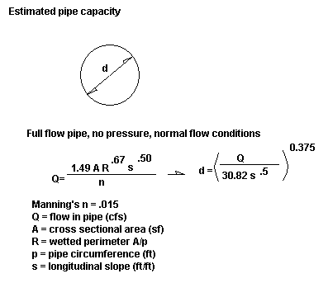

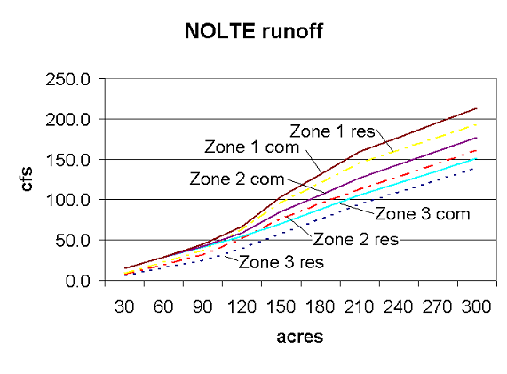

**Table A4**

|  |  |  |  |  |
| --- | --- | --- | --- | --- |
|  | Q in the pipe |  |  |  |
| Acres | Nolte ( zone 3) | 100-yr | Overland |  |
| 20 | 6.0 | 23.2 | 17.2 | cfs |
| 40 | 12.0 | 46.4 | 34.4 | cfs |
| 60 | 18.0 | 69.6 | 51.6 | cfs |
| 80 | 24.0 | 92.8 | 68.8 | cfs |
| 100 | 30.0 | 116.0 | 86.0 | cfs |
| 120 | 36.0 | 139.2 | 103.2 | cfs |
| 140 | 42.0 | 140.0 | 98.0 | cfs |
| 160 | 48.0 | 160.0 | 112.0 | cfs |
| 180 | 54.0 | 171.0 | 117.0 | cfs |
| 200 | 60.0 | 182.0 | 122.0 | cfs |
| 220 | 66.0 | 200.2 | 134.2 | cfs |
| 240 | 72.0 | 218.4 | 146.4 | cfs |
| 260 | 78.0 | 236.6 | 158.6 | cfs |
| 280 | 84.0 | 249.2 | 165.2 | cfs |
| 300 | 90.0 | 255.0 | 165.0 | cfs |

**Table B4**

|  |  |  |  |  |  |  |  |  |  |  |  |
| --- | --- | --- | --- | --- | --- | --- | --- | --- | --- | --- | --- |
|  | **cross slope =** | **2.00%** |  |  | **Half of 40' wide street section** | | |  |  |  |  |
|  |  | **<-------------------------- Q (cfs) per Longitudinal Slope ------------------------------->** | | | | | | | |  |  |
| d BOW (inch) | T (ft) | 0.02% | 0.04% | 0.06% | 0.08% | 0.15% | 0.25% | 0.50% | 1.00% | 1.50% | 2.00% |
| 0.0 | 13.1 | 0.69 | 0.98 | 1.20 | 1.39 | 1.90 | 2.45 | 3.46 | 4.90 | 6.00 | 6.93 |
| 0.0 | 13.1 | 0.53 | 0.75 | 0.92 | 1.06 | 1.45 | 1.88 | 2.65 | 3.75 | 4.59 | 5.30 |
| 1.0 | 15.2 | 1.48 | 2.09 | 2.56 | 2.96 | 4.05 | 5.22 | 7.39 | 10.45 | 12.80 | 14.78 |
| 2.0 | 15.2 | 2.79 | 3.95 | 4.84 | 5.59 | 7.65 | 9.88 | 13.97 | 19.76 | 24.20 | 27.94 |
| 3.0 | 15.2 | 4.43 | 6.27 | 7.68 | 8.86 | 12.14 | 15.67 | 22.16 | 31.34 | 38.38 | 44.32 |
| 4.0 | 15.2 | 6.36 | 9.00 | 11.02 | 12.73 | 17.42 | 22.50 | 31.81 | 44.99 | 55.10 | 63.63 |
| 5.0 | 15.2 | 8.56 | 12.11 | 14.83 | 17.13 | 23.46 | 30.28 | 42.82 | 60.56 | 74.17 | 85.65 |
| 6.0 | 15.2 | 11.02 | 15.59 | 19.09 | 22.05 | 30.19 | 38.97 | 55.12 | 77.95 | 95.46 | 110.23 |
| 7.0 | 15.2 | 13.73 | 19.41 | 23.77 | 27.45 | 37.59 | 48.53 | 68.63 | 97.05 | 118.86 | 137.25 |
| 8.0 | 15.2 | 16.66 | 23.56 | 28.86 | 33.32 | 45.62 | 58.90 | 83.30 | 117.80 | 144.28 | 166.60 |
| 9.0 | 15.2 | 19.82 | 28.03 | 34.33 | 39.64 | 54.28 | 70.07 | 99.09 | 140.14 | 171.64 | 198.19 |
| 10.0 | 15.2 | 23.19 | 32.80 | 40.17 | 46.39 | 63.52 | 82.00 | 115.97 | 164.01 | 200.87 | 231.94 |
| 11.0 | 15.2 | 26.78 | 37.87 | 46.38 | 53.56 | 73.34 | 94.68 | 133.90 | 189.36 | 231.92 | 267.80 |

The following examples assume constant slopes, flat super elevations, normal flow and neglecting ponding, but the serve well for comparison purposes.

Example: A 100 acre residential drainage shed, in Nolte Zone 3, must pipe 30cfs while the 100-year runoff is 116cfs. The remaining 86cfs must flow overland, down the gutter at 43cfs on each side. This flow can be conveyed at a depth less than 6” in the gutter if the longitudinal slope is greater than about .31%. However, if the slope is flatter, a large pipe will have to be installed to reduce the overland flow.

Example: For a sample 160-acre shed, the excess runoff in 100-year storm is 56.0 cfs flowing down each gutter. In this case, the longitudinal slope must be greater than 0.54%. If the slope is only 0.15%, the depth above back of walk is calculated at 9.2”; therefore, a larger pipe will be required.

Tables C4 is a compilation of pipe design flows (Nolte Method) for fictitious shed areas using impervious area of 50% in zone 3 (Figure 2-6 and 2-9 of the Sacramento City/County Hydrology Standards). The 100-year flow was taken from the charts for Sacramento Method (Figures 2-20 and 2-21 of the Hydrology Standards). Notice that ‘Nolte’ and Sacramento Method have different ‘zones’ (see maps, Figures 2-4 and 2-11 of the Hydrology Standards).

Subtracting the 100-year flow from the pipe design flow and dividing by two gives the half street flow. Comparing this flow to Table B and interpolating, gives the required longitudinal street slope if the flow is to be limited as required by Section 9-16C of the Improvement Standards. Assuming the pipe flow is normal and the pipe is sloped parallel with the street, the pipe size is determined (not used in these calculations other than to indicate the range of trunk pipes being considered). One might reasonably assumes that a typical pipe outfall is 48” diameter, in this example serving 160-acres. At a slope of 0.32% the 100-year flow can be safely conveyed to the open channel. This is typical in Zones 11B and 11C, but Zone 11A is often flatter.

Table D4 summarizes the results with street flow limits (from Table B4) for comparison with various longitudinal slopes. For example, a 100-acre shed area has a pipe designed to convey 29cfs and a 100-year runoff flow of 105cfs, the half street flow is 38cfs requiring a slope of .25% to safely convey. Looking at a larger shed area of 220 acres, the pipe conveys 101.6cfs and the half street 100-year overland flow is 49.0cfs, requiring a slope steeper than .38%. Table E4 provides additional example calculations of the effect of ‘Section 9-16C.’ As one considers the typical shed areas, one can deduce that if the slope is flat, less than 0.25%, the “typical” shed outfall pipe will have to be enlarged in order to convey more flow and to reduce overland flow in the street. Table F4 compares the effect of ‘9-16C’ on trunk drainage cost in various specific plan areas.

**Table C4**

|  |  |  |  |  |  |  |  |  |
| --- | --- | --- | --- | --- | --- | --- | --- | --- |
| 50% impervious area | | | |  |  |  |  |  |
|  | Q in the pipe | (Sac Zn 2) |  |  |  |  | Required | Normal Flow |
| Acres | Nolte  ( zone 3) | 100-yr | Overland |  | Q  (half street) | | Slope at 6" | Pipe Size (in.) |
|  |  |  |  |  |  |  |  |  |
| 40 | 8.0 | 52.0 | 44.0 | cfs | 22.0 | cfs | 0.08% | 27.6 |
| 60 | 15.0 | 70.0 | 55.0 | cfs | 27.5 | cfs | 0.13% | 32.0 |
| 80 | 22.0 | 88.0 | 66.0 | cfs | 33.0 | cfs | 0.18% | 32.8 |
| 100 | 29.0 | 105.0 | 76.0 | cfs | 38.0 | cfs | 0.24% | 35.4 |
| 120 | 40.5 | 122.0 | 81.5 | cfs | 40.8 | cfs | 0.28% | 40.1 |
| 140 | 52.0 | 137.5 | 85.5 | cfs | 42.8 | cfs | 0.31% | 43.1 |
| 160 | 67.0 | 153.0 | 86.0 | cfs | 43.0 | cfs | 0.32% | 47.1 |
| 180 | 80.0 | 169.0 | 89.0 | cfs | 44.5 | cfs | 0.34% | 49.9 |
| 200 | 93.0 | 185.0 | 92.0 | cfs | 46.0 | cfs | 0.37% | 51.9 |
| 220 | 101.6 | 199.5 | 97.9 | cfs | 49.0 | cfs | 0.41% | 52.7 |
| 240 | 110.2 | 214.0 | 103.8 | cfs | 51.9 | cfs | 0.45% | 53.4 |
| 260 | 118.8 | 227.3 | 108.5 | cfs | 54.3 | cfs | 0.49% | 54.0 |
| 280 | 127.4 | 240.7 | 113.3 | cfs | 56.6 | cfs | 0.53% | 54.5 |
| 300 | 136.0 | 254.0 | 118.0 | cfs | 59.0 | cfs | 0.59% | 54.9 |
| 400 | 214.5 | 315.5 | 101.0 | cfs | 50.5 | cfs | 0.43% | 69.0 |
| 450 | 254.0 | 346.0 | 92.0 | cfs | 46.0 | cfs | 0.36% | 75.9 |
| 500 | 293.0 | 377.0 | 84.0 | cfs | 42.0 | cfs | 0.30% | 83.1 |

**Table D4**

|  |  |  |  |  |  |  |
| --- | --- | --- | --- | --- | --- | --- |
| Acres | Nolte Q | Q-half st. |  |  | Q-half st. |  |
|  |  | (overland) |  |  | 6" flow |  |
| 40 | 8.0 | 22.0 |  |  |  |  |
| 60 | 15.0 | 27.5 |  | 0.06% | 19.1 | cfs |
| 80 | 22.0 | 33.0 |  | 0.08% | 22.1 | cfs |
| 100 | 29.0 | 38.0 |  | 0.15% | 30.2 | cfs |
| 120 | 40.5 | 40.8 |  | 0.25% | 39.0 | cfs |
| 140 | 52.0 | 42.8 |  | 0.38% | 47.0 | cfs |
| 160 | 67.0 | 43.0 |  | 0.50% | 55.1 | cfs |
| 180 | 80.0 | 44.5 |  |  |  |  |
| 200 | 93.0 | 46.0 |  |  |  |  |
| 220 | 101.6 | 49.0 |  |  |  |  |
| 240 | 110.2 | 51.9 |  |  |  |  |
| 260 | 118.8 | 54.3 |  |  |  |  |
| 280 | 127.4 | 56.6 |  |  |  |  |
| 300 | 136.0 | 59.0 |  |  |  |  |
| 400 | 214.5 | 50.5 |  |  |  |  |
| 450 | 254.0 | 46.0 |  |  |  |  |
| 500 | 293.0 | 42.0 |  |  |  |  |

|  |  |  |  |  |  |  |
| --- | --- | --- | --- | --- | --- | --- |
| **Table E4** |  |  |  |  |  |  |
|  |  |  |  |  |  |  |
| Compare piped storm drainage required per the proposed | | | | |  |  |
| revision to Section 9-16C of the Improvement Standards. | | | | |  |  |
|  |  |  |  |  |  |  |
|  | Longitudinal slope of storm drain pipe and street | | | | | |
|  | 0.15% |  | 0.25% |  | 0.50% |  |
| 30" pipe conveys* | 13 | cfs | 17 | cfs | 22 | cfs |
| Serving** | 59 | acres | 77 | acres | 100 | acres |
| Q-100yr*** | 69 | cfs | 82 | cfs | 103 | cfs |
| Max. Q-Street˜ | 60 | cfs | 80 | cfs | 110 | cfs |
| Req'd Q pipe | 9 | cfs | 2 | cfs | - | cfs |
| Pipe size * | 30" | okay | 30" | okay | 30" | okay |
|  |  |  |  |  |  |  |
| 48" pipe conveys* | 47 | cfs | 60 | cfs | 85 | cfs |
| Serving** | 132 | acres | 152 | acres | 187 | acres |
| Q-100yr*** | 131 | cfs | 145 | cfs | 175 | cfs |
| Max. Q-Street˜ | 60 | cfs | 80 | cfs | 110 | cfs |
| Req'd Q pipe | 71 | cfs | 65 | cfs | 65 | cfs |
| Pipe size * | 55 | inch dia. | 49 | inch dia. | 48" | okay |
|  |  |  |  |  |  |  |
| 54" pipe conveys* | 65 | cfs | 83 | cfs | 118 | cfs |
| Serving** | 159 | acres | 185 | acres | 258 | acres |
| Q-100yr*** | 155 | cfs | 172 | cfs | 223 | cfs |
| Max. Q-Street˜ | 60 | cfs | 80 | cfs | 110 | cfs |
| Req'd Q pipe | 95 | cfs | 92 | cfs | 113 | cfs |
| Pipe size * | 62 | inch dia. | 56 | inch dia. | 54" | okay |
|  |  |  |  |  |  |  |
| 60" pipe conveys* | 83 | cfs | 110 | cfs | 150 | cfs |
| Serving** | 185 | acres | 235 | acres | 333 | acres |
| Q-100yr*** | 172 | cfs | 210 | cfs | 279 | cfs |
| Max. Q-Street˜ | 60 | cfs | 80 | cfs | 110 | cfs |
| Req'd Q pipe | 112 | cfs | 130 | cfs | 169 | cfs |
| Pipe size * | 66 | inch dia. | 63 | inch dia. | 60" | okay |

*Assuming normal flow using Manning’s equation

**Using Sacramento County Design Runoff Curve “Nolte Method” Zone 3 Residential

***From Sacramento Method Chart Zone 2 at 50% impervious (note that reference to Zone 2 and 3 above are because the pipe design map than the county hydrology map use different zone designations).

~Using Table B, assuming standard 2% cross slope and 6” deep over back of walk, normal flow equal on both sides of the street, neglecting ponded volume in the sag areas.

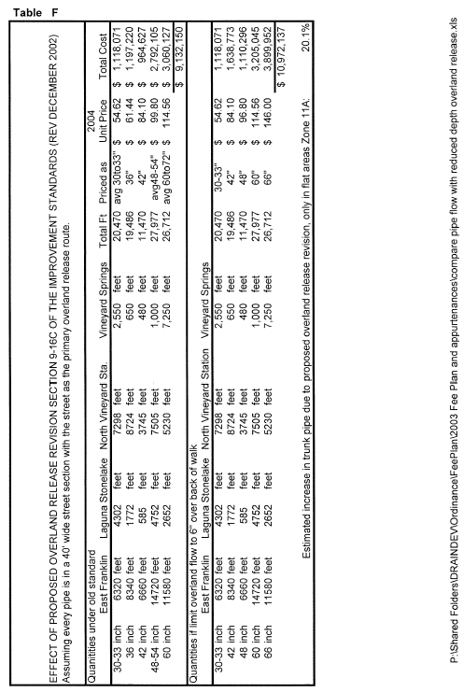It is recognized that pipe size increase is not always necessary and not all of Zone 11A is topographically flat; nevertheless, the impact of this standard is measurable. Reviewing East Franklin, Laguna Stonelake, North Vineyard Station, and Vineyard Springs Specific Plan Areas, pursuant to 9-16C, it was found that large diameter pipes in topographically flat areas will have to be upsized to reduce the 100-year flow in the street, see Table E. For example, a 48” pipe will serve 187 acres if the slope is 0.5%, but if the slope is 0.15% the same 187 acres will require a 66” diameter pipe. Table F concludes that the anticipated impact due to Section 9-16C is 20.1%.

In addition to Section 9-16C of the Improvement Standards, the reader is directed to the introductory paragraph under Section 9-16 in which the design engineer is required to limit the depth of ponding in the street to no more than 8” over back of walk, in the 100-year storm. When considering both of these standards, and the fact that it is desired to maintain passable collector streets in case of emergency, one should be reassured that pipe sizes should increase in many locations.

Recognizing that short of doing a detailed drainage master plan for the build out of Zone 11A, one is left with a decision of how to handle this apparent need for increase in pipe size. Based on review of the USGS quad map and the aforementioned design standards, it is agreed that the increase should be 56% [as calculated by Bill Owens, County DWR staff, on 8/18/03] of the 26% calculated increase (Table F); therefore a multiplier of 20.1% x .56 = 11.3% is used as an addition to the sum of the estimated trunk pipe costs in Zone 11A.

**Appendix 5 Revenue vs. Expense Past Five Years**

Below are revenue, expense, and cash flow statements for each Zone. This analysis will be kept current and the appendix updated annually.

Appendix 5A

Zone 11A Summary Past 5-Years

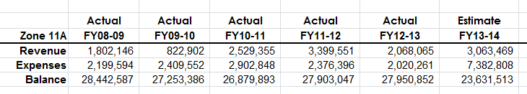

Development activity began increasing December 2013; consequently, the FY2013-14 credits, reimbursements, and right of way acquisition amounts are increased in the budget.

Appendix 5B

Zone 11B Summary Past 5-Years

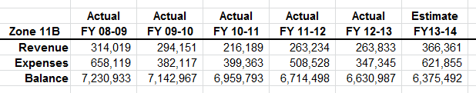

The FY2013-14 estimate includes estimated cost for pump station improvement projects.

Appendix 5C

Zone 11C Summary Past 5-Years

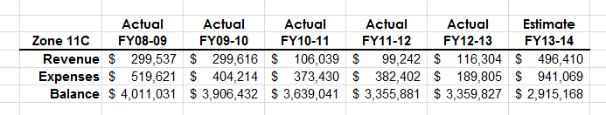

The estimate for FY2013-14 included an increase in credits applied against fees as the real estate economy begins to improve.

**Appendix 6 Projection of Revenue and Expenses**

This analysis will be kept current and the appendix updated.

**Zone 11A**

The Elder Creek and Gerber Creek improvements described in the North Vineyard Station Drainage Master Plan are permitted under the Clean Water Act and the work will be reimbursement heavy for the first several years.

There are many other opportunities for development in this fee zone and there is no accurate way to estimate which developments will go first and how the fee revenue versus reimbursement expenses will occur. Section 2.60 requires amortization of large reimbursement agreements so the actual yearly cash-flow may not be as shown.

Zone 11A accumulated a significant fund balance during the building boom of 2002 to 2007 and held those funds through the recession years of 2008 to 2013. Looking forward to development activity increasing, one must estimate the reimbursement load as trunk drainage facilities are constructed in the planning areas. The new development areas require installation of large trunk drainage facilities, potentially bearing significant reimbursement exposure. Later development projects will infill and pay a greater percentage of the Zone 11A fee in cash. These projections should be monitored each year as budgets are prepared.

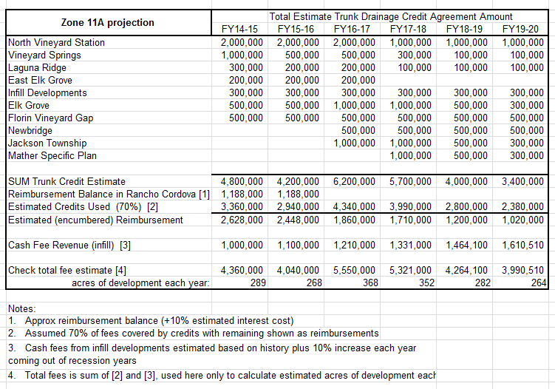

Projection estimates based on the assumptions described above. This table and chart will be maintained annually and this appendix will be edited.

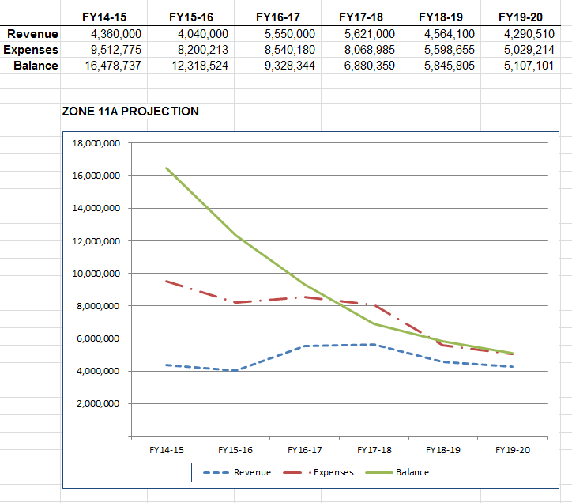

**Zone 11B**

Development opportunities in Zone 11B are limited to infill and redevelopment. Fees are charged for calculated increases impervious area, consequently, there will be a revenue stream continuing over the next many years. The following chart is based on an estimated $3,5329,000 contribution to the pump station upgrade project. The revenue is based on a nominal 30 acres per year of development at the (average) RD5 fee rate with an average of $54,000 per year in credits of which a nominal 20 percent is reimbursement cost. The average cash fee revenue is estimated at an average of $237,000 per year.

The projections should be monitored year over year to assure that the fund balance does not sink too low.

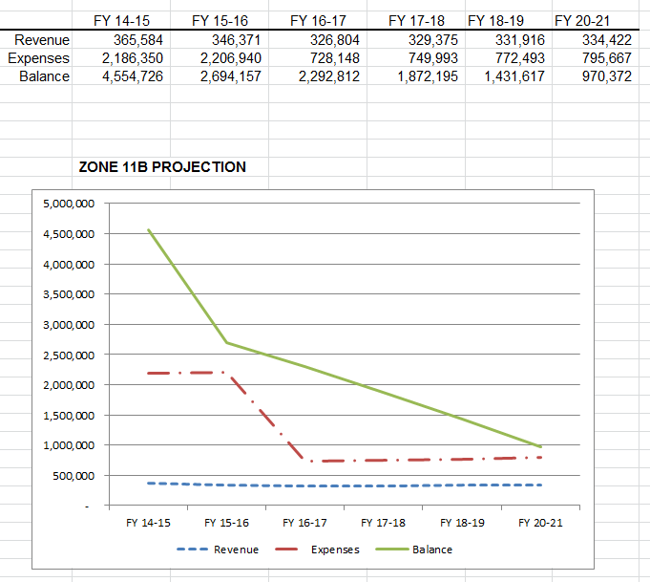

**Zone 11C**

The largest proposed development in Zone 11C is the Elverta Specific Plan in which Countryside is included. There are also opportunities to continue residential development in East Antelope, Barrett Ranch, and the area of Fox Creek. Zone 11C has much unimproved commercial and industrial land that may infill over time.

The fund balance is currently healthy, however as one can see from the estimate below, if development activity picks up in the fee zone the fund balance may begin to sink.

For the purposes of this analysis, the reimbursements are assumed to be 30 percent of the trunk drainage cost, and cash fee revenue is estimated to grow at a steady rate. Section 2.60 requires amortization of large reimbursement agreements so the actual yearly cash-flow may not be as shown.

It is important to watch this fund very carefully as the Elverta Specific Plan project breaks ground.

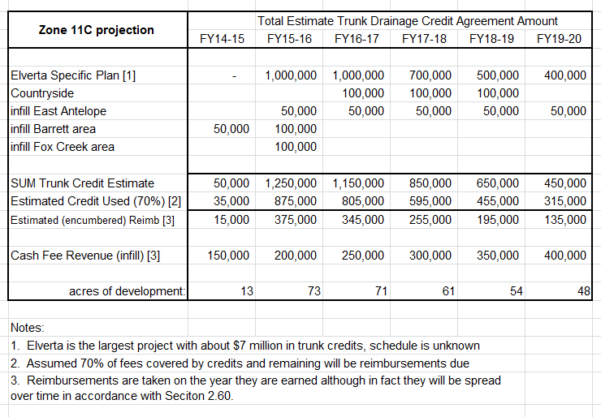

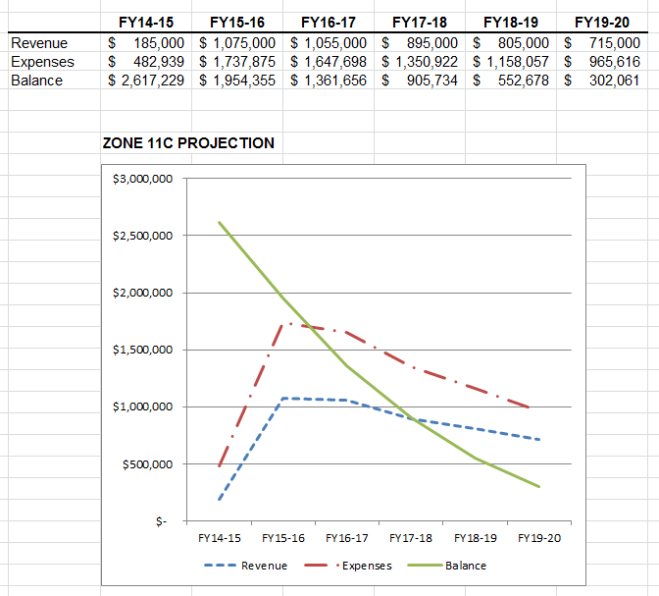

**Appendix 7 History of Zone 11 Drainage Fee**

Appx 7 Insert Fee History Commercial and RD5 Comparison

Appx 7 Insert History of Typical Credit

Appx 7 History of County Pooled Interest

**Appendix 8 Assignment of Credit Agreement Template**

The following template for assignment of drainage Credit Agreements describes the simplicity of the assignment while each party should assure that the form is adequate for their purposes.

ASSIGNMENT OF DRAINAGE CREDITS [DRAFT]

This Assignment (“Assignment”) is made this ____ day of 2______ by and between ______________________, a _________________ (“Assignor”) and _______________ a ____________________ corporation (“Assignee”), with reference to the following facts:

1. WHEREAS, Assignor is the owner of that certain real property located in the County of Sacramento, State of California commonly known as “____________________”, Assessor’s Parcel Number __________________ and more particularly described on Exhibit “A” to the Purchase Agreement and attached (the “Property”).
2. WHEREAS, an agreement for trunk drainage credits for Zone 11___ was signed by the Assignor, dated __________ and by the Director of the Sacramento County Department of Water Resources, dated ___________, (the “Credit Agreement”) pursuant to the Sacramento County Water Agency Code Titles I and II (the “Code”).
3. WHEREAS, the Credit Agreement lists quantities of estimated trunk drainage facilities to be adjusted based upon project completion, pursuant to the Code.
4. WHEREAS, pursuant to a Purchase and Sale Agreement dated _________, as amended (the “Purchase Agreement”), Assignor has agreed to sell to Assignee all of Assignor’s rights, title and interests in and to the Property, including, but not limited to Assignor’s right, title, and interest to certain drainage credits applicable to the Property pursuant to the Credit Agreement.
5. WHEREAS, Assignor and Assignee desire to enter into this agreement to confirm the assignment by Assignor to Assignee of all the Assignee’s rights to drainage credits and the Credit Agreement applicable to the Property.

**NOW, THEREFORE**, in consideration of the mutual covenants of the parties herein, and for good and valuable consideration, the receipt and sufficiency of which is hereby acknowledged, the parties agree as follows:

1. **Assignment By Assignor.**  Pursuant to ______ of the Purchase Agreement, Assignor hereby unconditionally sells, transfers and presently assigns the Credit Agreement to Assignee, without warranty or recourse (except as otherwise provided in this Assignment), all of Assignor’s rights, title and interest in and to the drainage credits applicable to ___________________ and pursuant to the terms of the Credit Agreement.
2. **Indemnity.** Assignor agrees to indemnify the Sacramento County Water Agency and the County of Sacramento and its employees against all liability, claims, damages, losses, costs, or expenses, including attorney fees and court costs, relating to the drainage credits applicable to the Credit Agreement, this Assignment, and the Purchase Agreement.
3. **Further Assurances.** Whenever requested to do so by the other party, each party shall execute, acknowledge and deliver any further conveyances, assignments, confirmations, satisfactions, releases, powers of attorney, and any further instruments or documents that are necessary, expedient, or proper to complete any conveyances, sales and assignments contemplated by this Assignment. In addition, each party shall do any other acts and execute, acknowledge, and deliver any requested documents in order to carry out the intent and purpose of this Assignment.
4. **Governing Law.** This Assignment is made and entered into the State of California and shall be interpreted, construed and enforced in accordance with the laws of the State of California.
5. **Binding Effect.** This Assignment shall apply to, bind, and inure to benefit of Assignor and Assignee, and their respective heirs, legal representatives, successors and assigns.

**IN WITNESS WHEREOF,** this Assignment has been executed as of the date first above written.

ASSIGNOR:

By: _______________

Its: _______________

ASSIGNEE:

By: _______________

Its: _______________

[signatures shall be notarized]